

**Programming Fundamentals**

**LAB ASSIGNMENT NO 1**

**SUBMITTED BY:**

HASAAN AHMAD SP22-BSE-017

**SUBMITTED TO: Sir Muzaffar Iqbal**

**TASK 1**

**Code:**

// HASAAN AHMAD SP22-BSE-017

public class LABQ_1 {

    public static void main(String[] args) {

        // Test Runs

        System.out.println(isValidDate(22, 12, 2023));

        System.out.println(isValidDate(29, 2, 2023));

    }

    public static boolean isValidDate(int day, int month, int year) {

        // Year !=0

        if (year < 1) {

            return false;

        }

        // Check if month is valid

        if (month < 1 || month > 12) {

            return false;

        }

        // Check if day is valid

        int maxDays = 31; // default max days for most months

        if (month == 4 || month == 6 || month == 9 || month == 11) {

            maxDays = 30; // April, June, September, November

        } else if (month == 2) {

            if (year % 4 == 0 && (year % 100 != 0 || year % 400 == 0)) {

                maxDays = 29; // For Leap year

            } else {

                maxDays = 28; // Non-leap year

            }

        }

        if (day < 1 || day > maxDays) {

            return false;

        }

        // Returns true if all the above conditions are satisfied

        return true;

    }

}

**Output:**

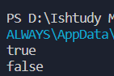

**TASK 2**

**CODE:**

// HASAAN AHMAD SP22-BSE-017

import java.util.Scanner;

public class LABQ_2 {

    public static void main(String[] args) {

        // TAKING USER INPUT

        Scanner in = new Scanner(System.in);

        System.out.println("Enter number of students: ");

        int size = in.nextInt();

        String[] StudentArr = new String[size];

        int[] marksArr = new int[size];

        for (int i = 0; i < size; i++) {

            System.out.println("Student Name " + (i + 1));

            StudentArr[i] = in.next();

            System.out.println("Student Makrs " + (i + 1));

            marksArr[i] = in.nextInt();

        }

        int leadMarks = highestMarks(marksArr);

        for (int i = 0; i < size; i++) {

            if (marksArr[i] == leadMarks)

                System.out.println(StudentArr[i] + " Has highest marks " + leadMarks);

        }

    }

    // GLOBAL VARIABLE TO MAINTAIN STUDENT WITH HIGHEST MARKS

    public static int highestMarks(int[] array) {

        int highest = 0;

        for (int j : array) {

            if (highest < j)

                highest = j;

        }

        return highest;

    }

}

**Output:**

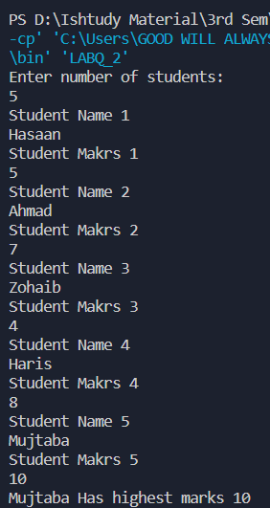

**TASK 3**

**Code:**

// HASAAN AHMAD SP22-BSE-017

import java.util.Arrays;

import java.util.Scanner;

public class LABQ_3 {

    public static void main(String[] args) {

        Scanner myObj = new Scanner(System.in);

        System.out.println("Enter The Size of");

        int size = myObj.nextInt();

        int[] array = new int[size];

        for (int i = 0; i < size; i++) {

            // PROMPTING USER TO ENTER VALUE

            System.out.println("Enter value " + (i + 1));

            array[i] = myObj.nextInt();

        }

        // CALLING DEFINED SORT METHOD

        sort(array);

        System.out.println(Arrays.toString(array));

    }

    public static void sort(int[] arr) {

        // USING NESTED LOOP TO SORT IN ASCENDING ORDER

        for (int i = 0; i < arr.length; i++) {

            for (int j = i; j < arr.length; j++) {

                if (arr[i] >= arr[j]) {

                    int temp = arr[i];

                    arr[i] = arr[j];

                    arr[j] = temp;

                }

            }

        }

    }

}

**Output:**

